The University of Bucharest
University of mathematics and Informatics
hiiiiiiiiiiiiiiiiiiiiiiiii
enter name

Software Project Management

Application: University Student Portal

Group 406,405
Hadel F. Abdalmaaen Makya

Bucuresti
2015

Contents
Part I | Business case ………………………………………………………………………………………………………………………….
1. | Project name: University Student Portal ………………………………………………………………………………..
2. | Objectives ……………………………………………………………………………………………………………………………..
3. | Motivation ………………………………………………………………………………………………………………………………
4. | Summary …………………………………………………………………………………………………………………………………
4.1 | Description The summary of product / service .....................................................................
4.2 | Description General solution proposed…………………………………………………………………………………….
4.3 | Description General implementation plan proposed………………………………………………………………..
5. | Details of the proposed solution………………………………………………………………………………………………..
5.1 | SWOT analysis ( Strength , Weakness , Opportunities , Threats )……………………………………………….
5.2 | Who do the same? (The market)…………………………………………………………………………………………………
5.3 | comparison with other solutions, advantages + disadvantages ………………………………………………….
5.4 | Possible acquisitions: observations about provider (Portfolio, support integration)……………………
5.5 | Technologies used: compatibility with hardware / software company……………………………………….
5.7 | Possible risks: identification, qualitative analysis / quantities, response plans…………………………..
5.6 | integration with other projects / operations of the company (if applicable)……………………………..
5.7 | Possible risks: identification, qualitative analysis / quantities, response plans…………………………..
6. | project impact…………………………………………………………………………………………………………………………….
6.1 | positive + negative influences on the organization……………………………………………………………………..
6.3 | which requires changes in the organization (temporary halt of activity, etc)……………………………..
6.3 | Benefits……………………………………………………………………………………………………………………………………….
7. | Costs…………………………………………………………………………………………………………………………………………….
7.1 | categories of cost + estimates………………………………………………………………………………………………………
7.2 | cost / benefit analysis (ROI, "payback period"……………………………………………………………………………..
Part II | Project Planning …………………………………………………………………………………………………………………………  The structure of this part is given below. V. and Chapter 3 of the book "Software Project Management "for explanation and examples:  http://highered.mcgrawhill.com/sites/dl/free/9780077122/700264/SPM_C03.pdf
1 | Identify project scope and objectives techniques………………………………………………………………………..
1.1 | Identify Objectives and Measures of Effectiveness in Meeting Them………………………………………….
1.2 | Project Authority has established……………………………………………………………………………………………….
1.3 | Identify stakeholders Modify ………………………………………………………………………………………………………
1.4 | Objectives in the light of stakeholder analysis Established ………………………………………………………….
1.5 | Methods of communication with all parties…………………………………………………………………………………
2 | Identify project's infrastructure Between ……………………………………………………………………………………
2.1 | established relationship and strategic planning project……………………………………………………………..
2.2 | Identify installation Standards and Procedures…………………………………………………………………………..
2.3 | Identify project team organization………………………………………………………………………………………………
3 | Analyse project Characteristics……………………………………………………………………………………………………
3.1 | Distinguish the project would either objective or product driven Analyze project 3.2 Other Characteristics……………………………………………………………………………………………………………………………..
3.3 | Identify high-level project Risks……………………………………………………………………………………………………
3.4 | Take into account user Requirements Concerning Implementation Select……………………………………
3.5 | overall lifecycle approach…………………………………………………………………………………………………………….
3.6 | Review Overall resource Estimates……………………………………………………………………………………………….
4 | Identify project products and activities…………………………………………………………………………………………
4.1 | Identify and describe project products (Including quality criteria)……………………………………………….
4.2 | Document Flows generic product………………………………………………………………………………………………..
4.3 | Recognize product instances……………………………………………………………………………………………………….
4.4 | Produce ideal network activity…………………………………………………………………………………………………….
4.5 | Modify ideal to take into account Need for stages and checkpoints…………………………………………….
5 | Estimate effort for each activity………………………………………………………………………………………………….
5.1 | Carry out bottom up Estimates (i.e. Efforts estimated for each activity, the then add Obtain Them to the effort for the whole project how many person months (town days / weeks) is Necessary to complete the project………………………………………………………………………………………………
6 | activity Identify Risks…………………………………………………………………………………………………………………….
6.1 | Identify and quantify activity based Risks……………………………………………………………………………………
6.2 | risk reduction plan and contingency measures The WHERE APPROPRIATE Estimates and 6.3 Adjust crying to take account of Risks
7 | allocate resources…………………………………………………………………………………………………………………………
7.1 | Identify and allocate resources…………………………………………………………………………………………………….
7.2 | Also Includes a Gantt diagram (required!)…………………………………………………………………………………….
Part III | code management (versioning control)  Use a management tool of code to simulate 3-4 programmers working 10 File making some changes (eg from operations commit). The aim is to demonstrate the work with code (without actually schedule)…………………………………………………………………………………………………………………………

Part I. Business case

1. Project name: University Student Portal
2. The purpose application (Goals)
Aims at developing a centralized portal for educational institutions for managing student projects and To implement and evaluate the student portal infrastructure as a way of managing the delivery of flexible lifelong learning To improve the learner experience by providing easy access to a personalized collection of essential information, applications and electronic resources .To enable the learner to log in once to access all the information, applications and resources .To provide a foundation for tracking flexible student learning plans across institutions .To enable learner interaction in business processes such as learner data reconciliation .To implement a service-oriented approach to integrate the enterprise applications in each consortium to provide dynamic data via web services .To improve enrolment operations between student record systems and VLEs via services.

3- motivation:
Motivation of this project is to implement a website for students for sharing Information exchange between teacher and student and between the student and another student. This application will be useful for every student to get updated to latest information and communicate with other students. This process of sharing information is innovative concept mainly this application will be helpful in sharing project related information in the process of implementing final year project.

4- Summary:
4.1. Description The summary of product / service
A student web portal would allow students to access online campus services, websites, and course information from one convenient location, using a single user ID and password. They would be able to customize the portal to their own liking, adding or deleting links to internal websites, internal news channels aimed at particular groups of students, and external information such as sports, weather, entertainment, etc.
The central goal is to transform the day-to-day operations of the University by reducing paperwork; putting more information services and transactions online; and streamlining access to course information and content. A student web portal would collect these campus services and functions into a single website, making it easy for students to find and use online services, and thus increasing the likelihood that the University can attain the strategic goals laid out A tab-based user interface provides the greatest flexibility for users and developers. Tabs allow students to toggle quickly between different types of information. As more online content becomes available over time, it is a simple matter for developers to add new tabs to accommodate and organize the new content. Allowing students to create and name some or all of the tabs on their personal portal pages wound give them the maximum flexibility in choosing how to organize information to suit their own needs.

4.2. Description General solution proposed

project is complete automated system. The proposed system is developed under the tool Visual Studio using Asp.net at front end and SQL Server as back end data storage purpose. By using the Web pages of asp.net with some web Technologies such as (HTMl ,Css ,Javascript , Jquery), our project with the user and store all the data on their corresponding attached SQL tables. System Architecture

HTTP Data
Clint
Browser Web
server
Microsoft ASP .Net

Database
Microsoft SQL Server

provider
client-server model

This application is modeled MVC(model -View -controller ) software architecture. Using logic models will hold information used by application (database tables). The database server is performed using Microsoft SQL Server 2012. View sites will be the basis GUI (Web pages viewed by the user). Controllers will contain the functional application that connects models and views (methods, variables, connection with other systems, etc.).
From the point of view of functional perspective, the following diagram illustrates the MVC Designee pattern of application.
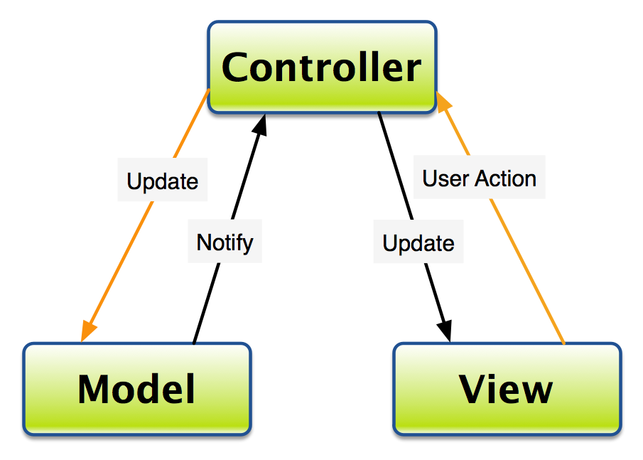
MVC software architecture
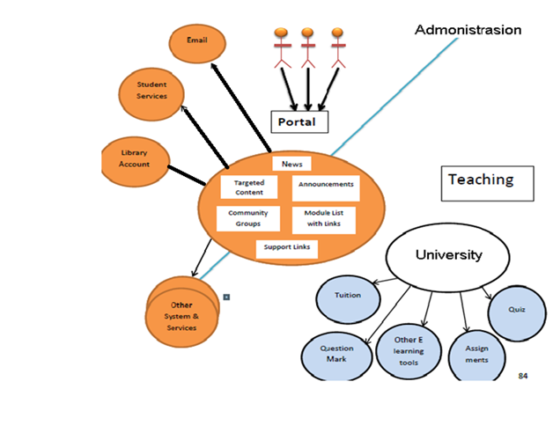

4.3. Description General implementation plan proposed
Product Functions
The final products will be
1. DBMS Host: A database will be responsible for keeping a track of Users login/ logouts. Users can be Faculty or students. The database will decide who to give the access and who not. The Database will keep a track of grading as well as their scores.
2. Online Quiz System: will allow the students to give online quiz. From university and to exceptional students to give online quiz from out of city.
3. Report Generator: would check the quiz according to the given answers given by the teacher and then will tell them the score and store it in the database.
4. Assignment Submission: assignments can be submitted on the website within time. After the given time. The submission facility will become disable. The assignment would go to the regarding teacher’s account.
5. Alerts: the interface will allow students to know about the quiz, assignments and the updates about the classes.
6. References: all the books, notes, slides will be available on the site in the specific semester folder. So that only the current student could have access
7. Video tutorials: are also going to be available on the website. There hyperlink to Video, YouTube and to other links are going to be available.
Technical Description:
Portal consists of:
Students login
- Teachers login
- Students Assignments Record
- Students Quizzes Record
- News for Teachers and students
- Books for Student
- Its benefits are:
- Students can check their accounts and their marks obtained
- Teachers can upload assignments
- Reduce the complexity
- Providing interface for staff and students to communicate on a single platform

5. Details of the proposed solution

5.1. SWOT analysis ( Strength , Weakness , Opportunities , Threats )
- Strength:-
1. Communication Environment:-
A unique current environment-appropriate for student and teachers communication. Student can contact teacher directly. No need to share your contact number.
- Easy to use:-
No need to hire a trained staff to guide how to use to project. User manual or a person with basic IT knowledge can use it easily.
- Environment Friendly:-
Website is environment friendly. It can be opened on Internet Explorer, Firefox, Google chrome, Speed Monkey and many more.
- Weakness:
- Network Failure:-
The software is totally dependent on internet. If you are not in a hotspot area or connected to internet you won’t be able to connect the website.
- Public view:-
Trust of office on one person who manages their personal information and cross check their messages and all. Might let them feel that they got no privacy.
- User Traffic:-
User crossing the limit when connect to website will increase load on site. And cause unavailability.

- Opportunities:
- Additional Features:-
With the increase of Market demand additional features can be added.
- Better Communication:-
A student who is not in contact with friends and teacher, he won’t have to rely on anyone to tell him which quiz or assignment is coming up.

- Threats:
- Hacked:-
In the situation of being hacked your personal information and data will be accessed.

5.2. Who do the same? (The market)
Currently there are many websites that are just providing teachers and students to data related to their field and concern like timetable, course outline and availability of staff:
https://uwaterloo.ca/student-portal/about
The student portal project is led by the Student Success Office (SSO), working collaboratively with Information and Systems Technology (IST).
The portal is a mobile-friendly communications tool for current students that pulls in the UWaterloo information students need, just when they need it.
- http://www.leeds.ac.uk/portal-project/
The institutional portal is intended to provide a seamless, web-based interface to a range of systems and services. The portal will also offer a customized, and potentially personal sable, web environment for staff and students.
- https://www.griffith.edu.au/information-services/publications/current-campaigns/student-portal-project
The Student Portal Project is one of the EICP projects being undertaken by the PPO portfolio
The goal for 2016 is to provide copy and design expertise to the project group and provide communication and digital designs at key project milestones.
- http://as.exeter.ac.uk/projects/portal/
The new portal, called exehub, will go live in September and will give students access to all their key documents, calendars and other resources at any time, from any location, and with any device. Users of exehub will be able to create and share documents at the click of a button, and will be able to take advantage of a brand new Microsoft Office suite.

- http://www.helwan.edu.eg/English/?page_id=237
Suggest a number of electronic services which is offered to the students, faculty staff members and society through the universities’ portal.
Determine the minimum rate of the required data which must be available at each university’s portal and train number of workers on editing, deleting and modifying the data on the portal periodically.

5.3. comparison with other solutions, advantages + disadvantages
Comparing our project with others we would say that we are trying our best to make it efficient and effective so that other departments of university can also adopt it. For this we are using languages like HTML5 so that software would say in market for a time.

5.4. Possible acquisitions: observations about provider (Portfolio, support integration)
The application can be presented in meetings Businessmen pursuing start-ups and want to invest (eg Connect Hub).

5.5. Technologies used: compatibility with hardware / software company
- Microsoft Visual Studio 2012
- Microsoft SQL Server 2012
- Microsoft SQL Server
- Stylus Studio® X15 Release 2 XML Professional Suite AUP - 1 User License
- Operating System
- Visual C++ Redistributable Packages for Visual Studio 2013
- Microsoft .NET Framework 4.5

GitHub - is a web-based Git repository hosting service. It offers all of the distributed revision control and source code management (SCM) functionality of Git as well as adding its own features. Unlike Git, which is strictly a command-line tool, GitHub provides a Web-based graphical interface and desktop as well as mobile integration. It also provides access control and several collaboration features such as bug tracking, feature requests, task management, and wikis for every project.
Asana ـ is a modern web application that keeps teams in sync, a shared task list where everyone can capture, organize, track, and communicate what they are working on in service of their common goal. Rather than trying to stay organized through the tedious grind of emails and meetings, teams using Asana can move faster and do more — or even take on bigger and more interesting goals.

5.6. integration with other projects / operations of the company (if applicable)

5.7. Possible risks: identification, qualitative analysis / quantities, response plans
Methodology includes:
- Risk identification
It is the process of risks that may affect the project and documenting their characteristics selected. Such as stop provider of a service or the process of updating the site stopped for some days or hours needed and this iterative processes that occur in all phases of the project life cycle. During the process of risk identification, and can identify potential risk responses. These responses serve a useful input for the planning process to respond to risks. a risk that is very likely to adversely impact the schedule , drive costs up or drive quality down.

- Conducting Quantitative Risk Analysis
The aim of quantitative risk analysis is to analyze numerically the probability of each risk occurring and its consequence on project objectives. The method for conducting quantitative risk analysis is twofold:
Firstly, data gathering occurs. A variety of tools and techniques are used to gather information that is then processed using the quantitative risk analysis tools. Next, quantitative risk analysis tools are used to assess risks against the project objectives.
These tools include
Interviewing
public review
decision tree analysis
sensitivity analysis
modeling and simulation

- The Risk Response Plan:
Information from the qualitative risk analysis is added to the risk identification template to deliver the risk response plan. The risk response plan is part of the project management plan and is used to track identified risks and the analysis. The information added to the risk response plan, in addition to the identified risks, includes
relative rating or priority list of project risks , which classifies risks according to
their individual significance a separate list can be done for each objective
risk categorization , which helps identify common causes of risk or areas that require attention .
list of risks requiring an urgent response
list of risks for additional analysis and response
watch list of low priority risks
trends in qualitative risk analysis results

6- project impact
6.1 positive + negative influences on the organization
positive ,You may each college - each section - all faculty members update the content of the site without reference to the management of the gateway project independently and under his responsibility, nor take the publishing process in this case only a few sec.
negative , When any college - section - faculty members wants to add any features to the project he must return to the project management.

6.2 which requires changes in the organization (temporary halt of activity, etc)
. codes Departments faculty .
· codes Academic programs and disciplines sections in college .
· codes College faculty members divided into sections and disciplines.
· Faculty files, which files you will turn to the pages.
· Study programs (list of each discipline) undergraduate.
· Study programs (list of each discipline) for post-graduate studies.
· Developments faculty also includes quality projects.
· Research projects altogether.

6.3 benefits
. Showing provide biographical official statements.
· Allow viewing a particular site for each faculty member is managed by himself and has a free hand in its preparation and organization.
· The opportunity to download lectures - exams models - issues and questions and send them to students solutions.
· Providing access to scientific degrees enrollment requests (diploma -master -Ph.D.).
· Show looking at their exam schedule.
· Show looking at their exam results.
· View courses prepared by the E-Learning Center on the portal.
· View news conferences and workshops.

7. Cost
The amount of time it took to develop these portals ranged from eight months to one year. The number of staff involved varied from two to 6 people. Funding levels also varied widely, from less than 59,772 $ to 100,000 $. There was no correlation between level of funding and the length of time it took to complete the project. However, there was a direct correlation between the level of satisfaction with the portal and the length of time the portal had been in production.
We did find some common experiences. All institutions report that the technical management of the portal resides in an information technology unit. All believe that high-level executive support was key to the success of their portal development project.
The portal doesn’t have to be expensive. However, it does need support at the highest level of administration, and it needs steady and ongoing funding throughout its life. Content providers (both staff and faculty) need training, consultation, and acknowledgment and reward for doing their jobs in new ways.
This table shows us the software and hardware used for the salary of each person and the number of people and the total salary:

Hardware
NO | Name | Notes | price | Quantity | total price
1 | laptop | Lenovo , CI 7 ,RAM 8 GB, display adapter 2 GB | 700 $ | 6 | 4200 $
2 | SERVER | Dell PowerEdge T620 , Processor Speed: 2.70GHZ , RAM 32GB , Number of Processors: 1 , HD 10 T | 3000 $ | 2 | 6000 $
3 | L2 Switch 48 PoE | HP 2530 J9772A ProCurve 48 Port Gigabit Switch | 1200 $ | 2 | 2400 $
4 | Firewall (rotuer) | cisco ASA 5508 | 2000 $ | 1 | 2000 $
5 | Access Points | Ruckus | 300 $ | 20 | 6000 $
6 | AP Controller | ZoneDirector 1100 | 1500 $ | 1 | 1500 $
7 | Server Rack | TRIPP LITE 18U 33-Inch | 618 $ | 1 | 618 $
8 | UPS | APC 3000 | 1500 $ | 2 | 3000 $

Software
NO | Name | Notes | price | Quantity | total price
1 | Operating System | Window 10 professional | 200 $ | 6 | 1200 $
2 | Microsoft Office 2016 |  | 160 $ | 6 | 960 $
3 | Anti-Virus | Kaspersky Internet Security | 25 $ | 6 | 150 $
4 | Microsoft Visual Studio 2012 |  | free | 6 | free
5 | Microsoft SQL Server 2012 |  | free | 6 | free
6 | Stylus Studio® X15 Release 2 XML Professional Suite AUP - 1 User License |  | 130 $ | 6 | 780 $
7 | Operating System | Windows Server 2012 Datacenter | 882 $ | 2 | 1764 $
8 | Visual C++ Redistributable Packages for Visual Studio 2013 |  | Free | 6 | Free
9 | Microsoft .NET Framework 4.5 |  | Free | 6 | Free
10 | Asana |  | free | 6 | free

Miscellaneous
NO | Name | Notes | Price per month | Quantity | total price per month
1 | Programmers | 6 = The number of people  The number of Month = 8  48 = The total number of salaries in eight months  3600 = Salary and one month for each person  28.800 = Total amount for all months and people | 600 $ | 6x8=48 | 3600 $x 8 = 28800 $
2 | Internet provider | 200 Mbps down/upload | 50 | 8 | 400

Total Amount of Money 59,772 $

Part II Project planning
1. Identify project scope and objectives techniques
To define the scope of the project, it is important to identify the flowing:
Project objectives
- Goals.
- Sub-phases.
- Tasks.
- Resources.
- Budget.
- Schedule.
Once these parameters are established, the limitations and parameters of the project need to be clarified and identify the aspects that are not to be included in the project. When doing this, the project scope will make clear to the stakeholders, senior management and team members what will and will not be included in the final product or service
The main purpose of the product is to provide a better itinerary planning and facilitating communication between people. Thus one can distinguish the following objectives:
- Definition project portal.
- The purpose of downloading important documents on the gate.
- other business.
- Services.
- student
- Staff Services.
- Visitor Services.
  - Identify Objectives and Measures of Effectiveness in Meeting Them Understand the project objectives
To define the project scope, it is important to first establish the objectives of the project, which may include a new product, creating a new service within the organization, or develop a new piece of software. There are a number of objectives that could be central to a project and it becomes the role of the project manager to ensure that the team delivers that result according to the specified features or functions.

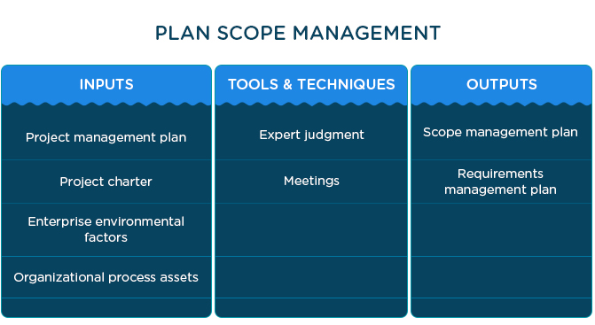

The project objectives:
- Portal services for undergraduate students .
- Show the results of the examinations.
- Showing the internal regulations of the College
- Ensure the quality of the questionnaires declared
- Providing conversion forms from colleges.
- Update and manage news content and advertising
- Student Housing and admission to university cities requests.
- Provide registration forms for students calve between departments and disciplines.
- Show school timetable and exam schedule.
- View courses prepared by the National Center for e-learning on the portal.
- Allowing students to choose one of the elective courses in accordance with the system of its own college.
- Portal services for Graduate Studies
- Show exams schedule.
- Showing news conferences and workshops.

Achieving efficiency targets will be measured by evaluating the following factors'
- Complacency users connected to the quality informational application 4. The total number of users who frequent application .
- Global Professionalism Standards .
- Scheduling .
- Academics and Attendance .
- Connect: The Student Portal . Full Sail Online: The Online Student Portal.
- Changes in Student Status .
- 10 Library .
- Student Services .
- Additional Services for Students with Disabilities .
- Family Educational Rights and Privacy Act .
- Safety Information .
- Student Activities .

1.2. Project Authority has established
- Administrator.
- Professors.
- Employee.
- Student.
Parties involved: ITS, Academic Services Division, Student Affairs

1.3. Identify stakeholders
The project has an impact on a large number of people. The main stakeholders of this project are:
- Ministry of higher education.
- Universities.
- Students.

1.4. Establishing methods of communication between all parties involved
The parties involved are the developers (the team that will develop) + person is promotion application.
Communication will be made in several ways: Oral communication: weekly meetings,
email, Asana OR GitHub (where they can see tasks and how they are organized).

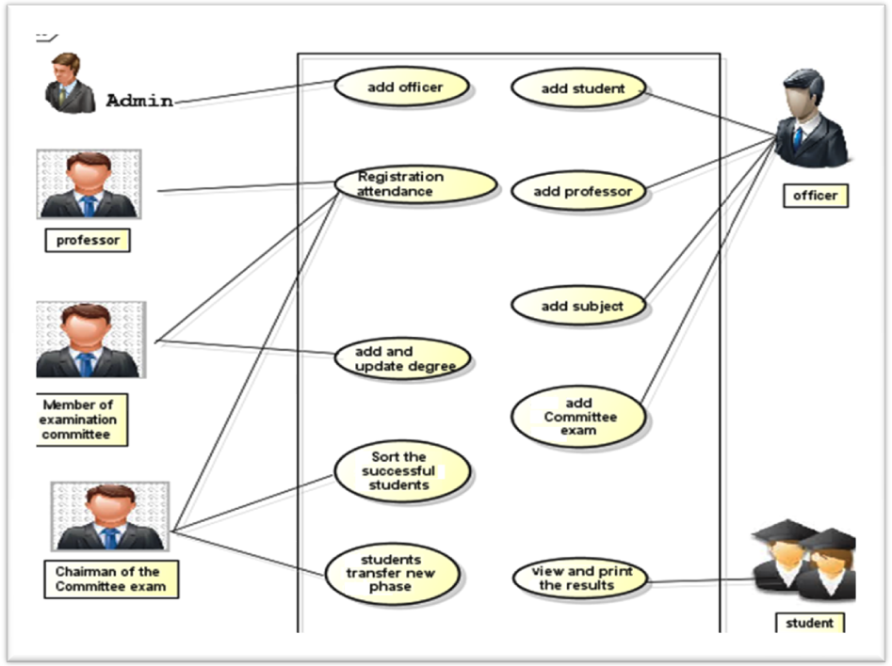

Figure (1) Use case diagram

2. Identify infrastructure project
There is usually some kind of existing infrastructure into which the project can fit. The project leader who does not already know about this structure needs to find out its precise nature.
2.1. Between established relationship and strategic planning project
■ To determine the order of related projects (being carried out )
■ To establish a framework within which the system fits.
■ To ensure the hardware and software standards are followed .
■ order of projects .
■ hardware & software standards to be met.

Figure (2) shows the use CASE of log in process through the web environment. Figure (3) presents the report use case of the system administrator and officer(s). Figure (4) shows the use CASE of the head and a member of committee exam. Figure (5) presents the use CASE of teaching (i.e., professors) and students.

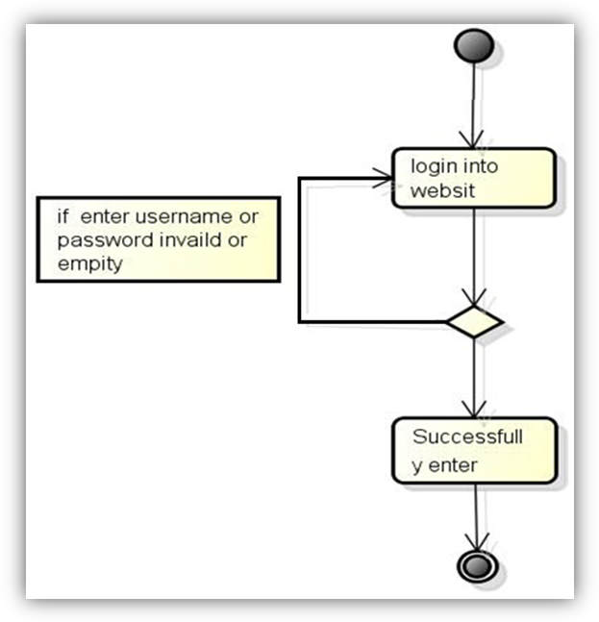
Successfully enter

enter
enter
Figure (2) The report use case login into website
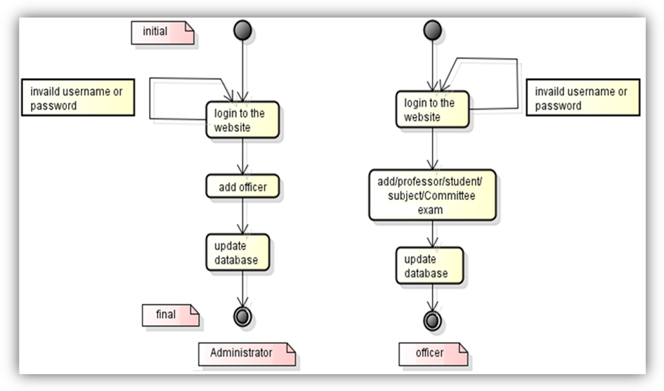Figure (3) The report Use case administrator and officer state diagram 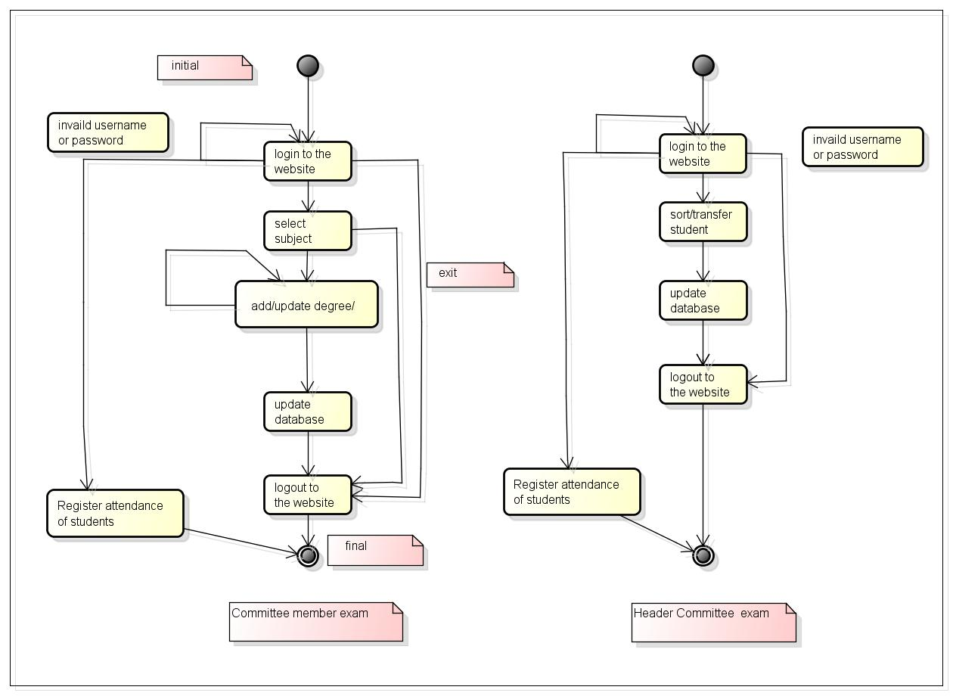
IT
Figure (4) Report state diagram member committee exam
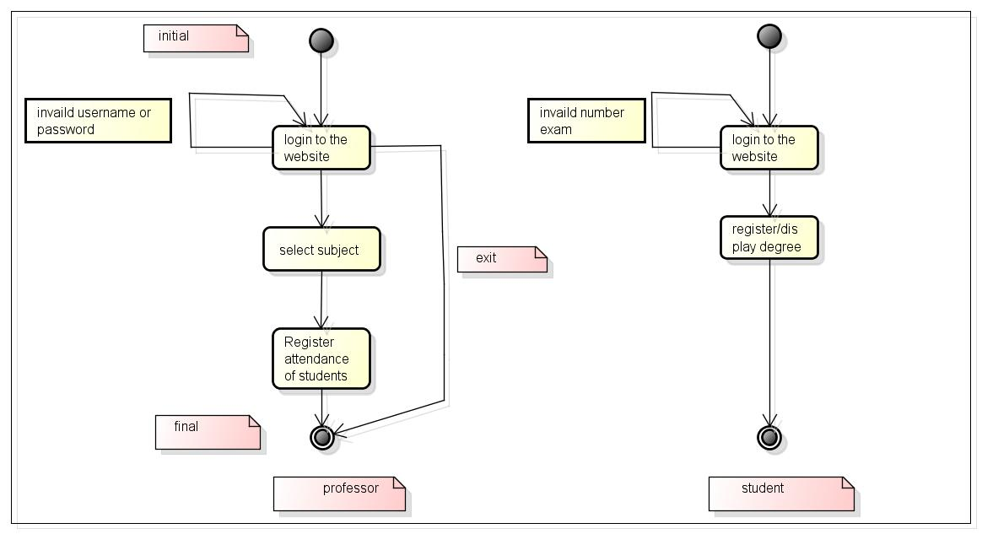
Figure (5) Report state diagram professor and student

2.2. Identify installation Standards and Procedures
An important role is played by the project in the availability of resources in different areas. Resources include team development, information held by them or obtained from various sources, money funds, natural resources and last time ethnology . To ate types of resources are limited, standards and procedures related to the software project .
making sure that all changes are documented, approved and reviewed • specifying which measure of quality are to be used and when.
therefore, they must be used in an efficient way, in order to complete the project in time.
Limitations (constraints) related to the project start date, end date thereof and the place can sometimes lead to urgent situations that can affect normal development approach designs (leading even to extend the period of application development ) .
2.3. Identify project team organization
There are mainly three kinds of system users for the model, they are
1 - Administrator1
2- Officer
3- Customer
Figure (6) presents the processes, Team, interactions taken into consideration in the developed model.

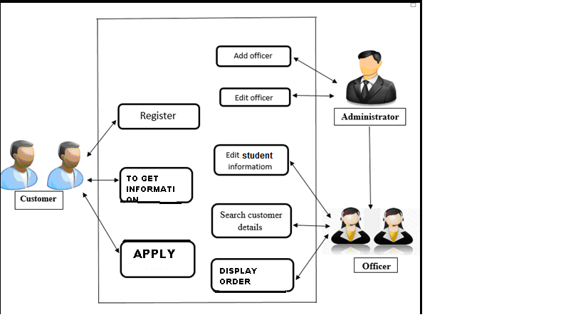
Figure (6) Use Case Model

3. Analyze project characteristics

When a visitor goes to a Web site written in Asp , the server reads the Asp.net code and then processes it according to its scripted directions. In the example shown in Figure i.2, the Asp.net code tells the server to send the appropriate data—HTML code—to the Web browser, which treats the received code as it would a standard HTML page .

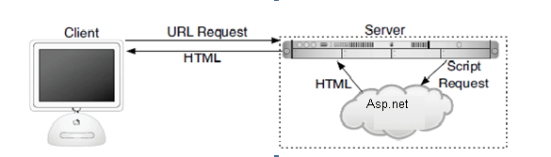
Figure 7 How Asp.net fits into client/server model when user requests a web page

3.1. Distinguish the project would either product-driven or objective
objective driven will give you more freedom but often there is a specified product you have to build to form a solution:

• essentially considering non-functional requirements:
• safety critical?
• sensitive data?
• speed/space requirements?

3.2. Analyze other project characteristics

important role in the project is played by the availability of resources in different areas. Resources include team development, information held by them or obtained from various sources, money funds, natural resources and last time technologies .All types of resources are limited, therefore, they must be used in an efficient way, in order to complete the project in time.
Limitations (constraints) related to the project start date, end date thereof and the place can sometimes lead to urgent situations that can affect normal development approach designs (leading even to extend the period of application development).

3.3. Identify high level project risks
- There are general risks which may occur at any time and may have a negative impact on the project:
- material risks: lack of internet connection, power shortage, failure of a laptop.
- wrong estimates of data on activity in the phase.
- team is not motivated to finish in time.
- reducing development team.

3.4. Take into account user Requirements Concerning Implementation
- Viewing issues and events announced by the university and the things related to them personally and located in their page.
- Apply for admission as well as financial aid requests.
- Review their classrooms and exam schedules.
- Request their own documents.
- Their own account management.
- Access to financial aid details.
It can be for administrators and teachers:
- The introduction of the midterm and final grades for each student.
- Write notes to be displayed in the student's file.
- Display tables classroom.
- View a list of students who have passed the exams and who could not pass the exam.
- Send a private message to one student, or a selection, or all of the students in the class, "with just one click."
- Information regarding the classroom, such as the beginning and end of the season and the days and times, location

3.5. Select overall lifecycle approach

Implementation Methodology and project development is consistent with design chosen.
Establish a backup system: keep the manual system running in-parallel during the development and testing phases. If something goes wrong with the new system during these phases, no data will be lost and cooperative operations will continue to operate smoothly.
• staff available
• time available
• distribution of resources

3.6. Review overall resource estimates
they are important resources in the project. Therefore, we can say that the results you'll get depends on the resources used.
- Human resources: people, knowledge, skills.( 6 software with skills and experience ).
- Financial resources (10000 $ ) .
- material resources: (6 laptops, The allocation of the entire wing of the building university) .
- effort ( 48 person - month )
- time ( 8 months )
For all the resources to turn a successful application is required and a lot of balance and organization of the team. need be revise cost estimates, team organization and risks .

4. Identify Project Products and Activities
- activities should produce tangible products:
- also includes technical products:
- training manual, operating instructions
- intermediates - used in the process of creating deliverables
- also includes planning and quality products:
- uml documentation, test cases
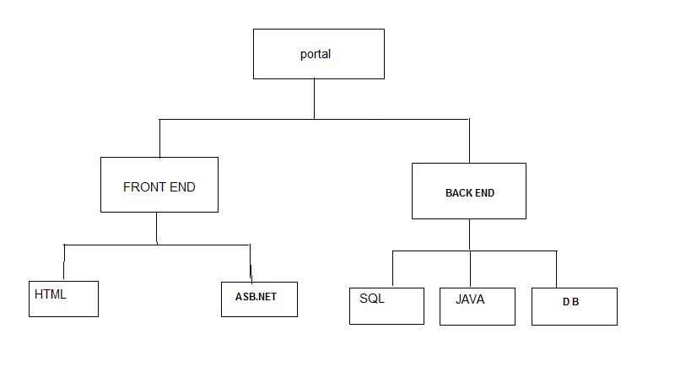
Activities: Inputs, Tools & Techniques, and Outputs

4.1. Identify and describe project product (Including quality criteria)
Existing products:
of management:
a planning tasks for the development of the projector.
a necessary resource planning application during development and testing.
of system:
functionalities in a presentation that contains the application's Timeline studies.
- related application modules:
a design.
a code.

4.2. Document Flows generic product
• some products cannot be created until other products exist
• these relationships can be captured in a product flow diagram:

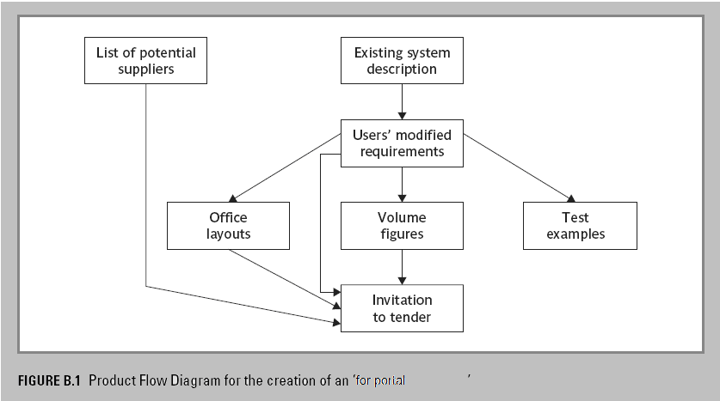

4.3. Recognize product instances

Identify all tasks required to attain each objective: key human resources, capital requirement and budget, formal risk analysis, software test plans, training plans, and implementation plans. Define time and resources for each. Define and estimate costs. Assign tasks to individuals or groups of individuals.
• spot when the same PFD fragment relates to many instances of a type product
• that might allow you to
• re-use the plans for the activities which produce it
• assign team members to undertake groups of activities with similar pfd

4.4. Produce ideal network activity
'ideal' because resource constraints are not taken into account
- Identify the activities needed to create each product in the PFD
- More than one activity might be needed to create a single product
- Hint: Identify activities by verb + noun but avoid ‘produce…’ (too vague)
- Draw up activity network

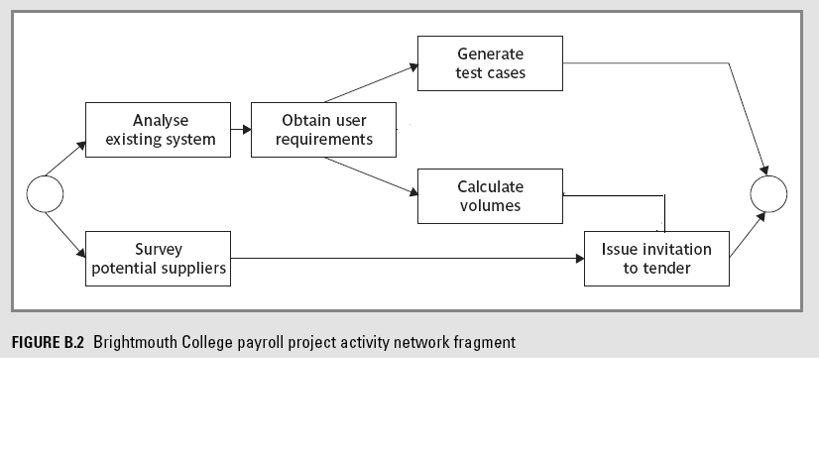
4.5. Modify ideal to take into account Need for stages and checkpoints
• sequencing activities in 4.4 encourages a plan which will minimize the project time.
• it assumes that a dependent activity can start as soon as the preceding ones have completed.
• in reality we will want to divide the project into stages and introduce checkpoint activities...
Checkpoint Activities & Milestones
• checking that products are compatible
• just after a checkpoint is a good place to add a milestone:
• a dummy activity with no duration.
• indicates the start or end of a group of activities.
• can represent the completion of an important stage of a project.
• so useful for ensuring that overall monitoring of the project (such as by the project authority) takes place regularly at appropriate points.
There are some points in the project when we want to check that the quality of what we have done so far is a sound basis for further work. In the example we have decided to check that all the module designs are compatible with one another before continuing. Note that the benefit of reducing wasted work at a later stage when incompatibilities lead to products being reworked, has to be balanced against the delay caused by the check-point. The start of coding of modules A, B and C all have to wait for the completion of the design of all the modules A, B and C. With no check-point, module A could be coded as soon as the design of module A had been done without having to wait for B and C.

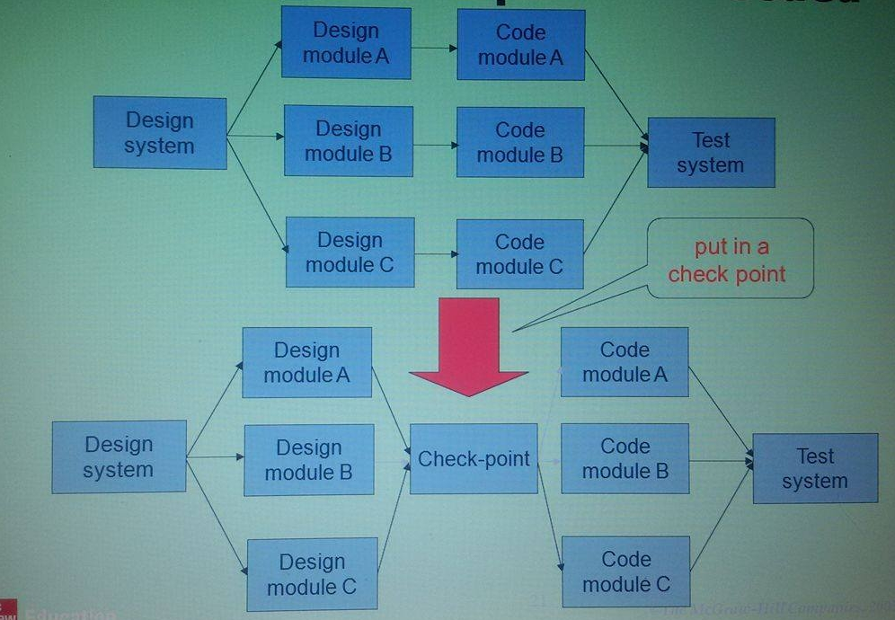

5. Estimate effort for each activity

5.1. Carry out bottom-up estimates
Bottom-up estimate is based on a reverse approach, from general to detail. This estimate requires extra effort for detailing all activities. We are interested to estimate costs and times, because we want to know when the project lasts and how its performance cost us in total. To estimate the cost of an activity need to know how long you can run, that human or material resources will be involved in the execution of activities. To begin the process of estimation should we assess the effort required to execute each activity, ie we need to know the hours of work involved in each activity.
Transformation requires hours of effort during quantify issues such as human resource productivity, the workload with other activities, the level of training and the number of available resources. To achieve more accurate estimates of duration, we must take into account all these factors, so that the project estimates are realistic

the activities | month of individual activity
HTML | 12
ASB . NET | 8
SQL | 6
JAVA | 12
DB | 10
TOTL | 48
The individual activity estimates of effort should be summed to get an overall bottom-up
5.2 Revise plan to create controllable activities

need to break a task into a series of manageable sub-tasks
- break up very long activities into a series of smaller ones
- bundle up very short activities (create check lists?)
- long activities (say 12 weeks) make a project difficult to control
- after 6 weeks are we 50% complete?
- can be hard to tell
- better to break down into smaller subtasks
- conversely, some very short, connected activities might be better bundled together, with a simple checklist
- roughly aim for activities to match the length of the reporting period
- if you have progress meetings every 2 weeks, try to identify activities which take two weeks .

6. activity Identify Risks
The risk was identified. Identifying risk is both science and art: the science uses the lessons of the past to systematically predict the future while the art blends the historical data with the intuition and insights of project stakeholders. Both art and science demand knowledge of project management and an understanding of the technology of the project. There are many techniques for identifying risks, but they fall into four major categories: asking the stakeholders; checking against a list of possible risks (a risk profile); learning from similar past projects; and analyzing the schedule and budget.
6.1. Identify and quantify activity-based risks
Identifying risks and acting accordingly are important prerequisites for a successful portal project, as the occurrence of a risk may cause costs, endanger the achievement of objectives, As the amount of risk is increasing with project scope and complexity, the professional management of risk factors is often crucial for the success of the portal. By considering the consequences and the probability of each risk, it should be possible to determine the importance of key risks. Here, it is important to involve risk management during the project planning phase Table shows typical risk factors when planning a portal.

Risks | Examples
Personnel risks | - Insufficient project management
Financial risks | - Low budget - Budget cutting
Deadline risks | - Failure to meet deadlines
Acceptance risks | - Risk of low acceptance rate by customers (end users)
Technology risks | - Compatibility problems - Problems with legacy systems -Interface problems

6.2. risk reduction plan and contingency measures The WHERE APPROPRIATE
  - risk reduction: activity to stop risk occurring
  - contingency: action if risk does occur
- reduce where possible
- otherwise specify a contingency plan
- for example: contract temporary developer if team member becomes unavailable through illness

6.3. Estimates and Adjust crying to take account of Risks
e.g. add new activities which reduce risks associated with other activities e.g. training, pilot trials, information gathering Note that we have already considered some high level risks that could affect the project. Estimates of the effort and duration of activities can be quite tricky. When you produce an estimate for an activity it is worth reflecting about the events which could cause the assumptions upon which you have based your estimate to be wrong. Where the risk seems very high, then you might try to introduce new activities specifically designed to reduce the risk, or to formulate a contingency action if the risk should materialize.

7. Allocate Resources

When the initial schedule has been calculated, the project schedule begins to take shape. One of the key features of the initial schedule is the critical path. The term critical path is one of the most widely used and most widely misunderstood of all project management terms. However, the concept is simple The critical path is defined as all of the tasks with zero or negative float. When outlined on a network diagram, the critical path is the longest path through the network.
Quality is continuous improvement through reduced variation.
1. The central problem in lack of quality is the failure of management to understand variation. (Everything varies. Statistics help us to predict how much variation there will be.)
2. It is management's responsibility to know whether the problems are in the system or in the behavior of the people.
3. Teamwork should be based on knowledge, design, redesign. Constant improvement is management's responsibility.

7.1. Identify and allocate resources
You now need to allocate resources (in particular, staff) to the activities in the plan. Where there is a resource constraint, that is there are not enough staff (or other resource) of the right type to start all the activities that run in parallel at the planned time, then the start of some activities may need to be delayed until the appropriate resources are available.
No | name | working month | work
1 | Joni fadi | 4 | HTML
2 | Yasser ali | 3 | ASB . NET
3 | Toti | 2 | SQL
4 | Exav | 2 | JAVA
5 | monika | 3 | DB

7.2. Revise plans and estimates to take into account resource constraints
  - e.g. staff not being available until a later date
  - non-project activities
• where there is conflict establish an order of priority
• note effects upon project duration
• a GANNT chart can help resolve conflict and maximize productivity...
Gantt charts are a staple tool in project management. They’ve achieved this status because of their ability to visualize the timeline of a project and the resources needed for it. But with the plethora of different visual tools you can now use to track projects, why even use a tool that was invented in 1910 and originally intended for machine shop production?

companies or departments overseas.
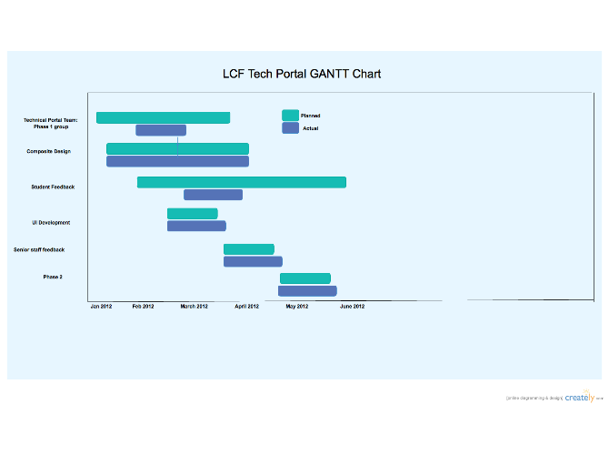

Easy to use Gantt chart template
A Gantt chart can be used to produce an accurate timescale for the project as well as:
- Breaking down the structure
- Showing team members how their work relates to others
- Schedule of work on a day to day basis throughout the entire duration
- Able to be used in the critical path method

